|  |  |
| --- | --- |
| NAME | Muhammad Arslan Raza |
| ROLL# | 2020-EE-403 |

**Lab 7: Problem Set 2**

**Objective:** The objective of this problem set is how to write different programs on compiler

**Task 1:**

Implement a code that estimates the value of mathematical constant ‘e’ according to the following formula:

$$ⅇ=1+\frac{1}{1!}+\frac{1}{2!}+\frac{1}{3!}+⋯$$ Adding more terms to calculate ‘e’ will make the value of ‘e’ more accurate. Prompt the user to  
enter the number of terms for the desired accuracy of the value of ‘e’

**With for Loop:**

**Code:**

x=int(input("Enter the Number"))

factorial=1

e=1

for i in range(1,x+1):

factorial=factorial*i

e=e+(1/factorial)

print("e=",e)

**Output:**

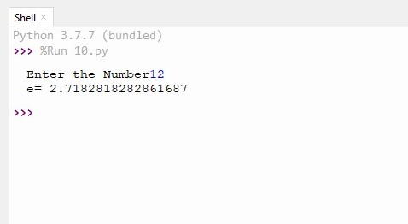

**With while Loop:**

**Code:**

x=int(input("Enter the Number"))

factorial=1

e=1

i=1

while i<x:

factorial=factorial*i

e=e+(1/factorial)

i=i+1

print(e)

**Output:**



**Task 2:**

Ask the user to provide final exam marks of 10 students in *Introduction to Computing* course in order to calculate the average. Use *while* loop for this purpose, and use *break* statement to exit the loop when an invalid input (e.g. negative number) is given. Moreover, if marks greater than 100 are given, use *continue* statement to skip that number from average calculation.

**Code:**

n=0

sum=0

while n<10:

x=int(input("Enter the marks"))

if x<0:

break

if x>100:

continue

n=n+1

sum=sum+x

print("average marks of student=",sum/10)

**Output:**

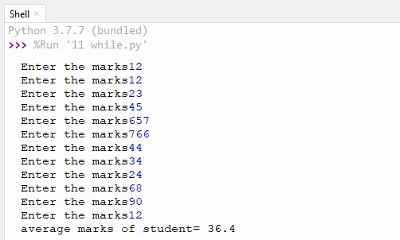

**Task 3:**

Write programs that print following patterns separately

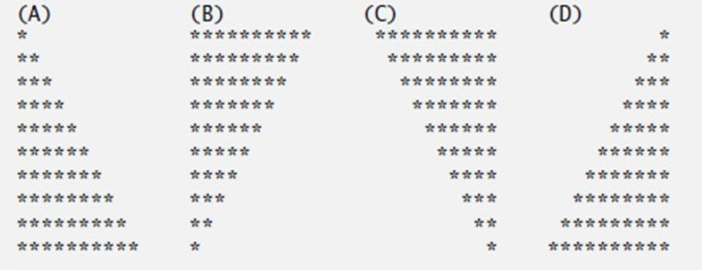

**A:**

**Code:**

x=int(input("Enter the number of rows"))

for i in range(1,x):

for j in range(0,i):

print("*",end="")

print()

**Output:**

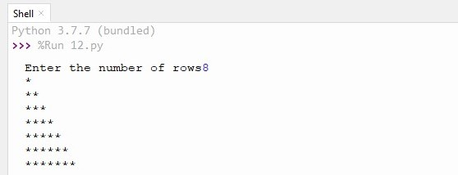

**B:**

**Code:**

x=int(input("Enter the number of rows"))

for i in range(x,0,-1):

for j in range(0,i):

print("*",end="")

print()

**Output:**

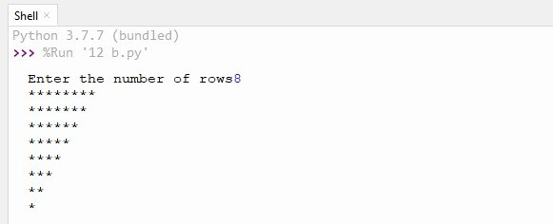

**C:**

**Code:**

i=1

while i<11:

i=i+1

k=0

while k<i:

k=k+1

print(" ",end= "")

j=11

while j>i-1:

j=j-1

print("*",end= "")

print()

**Output:**

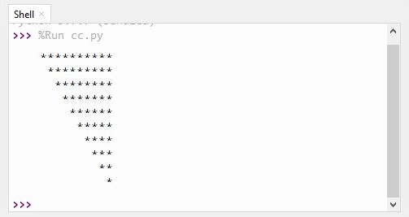

**D:**

**Code:**

i=1

while i<11:

i=i+1

k=10

while k>i-1:

k=k-1

print(" ",end="")

j=0

while j<i-1:

j=j+1

print("*",end="")

print()

**Output:**

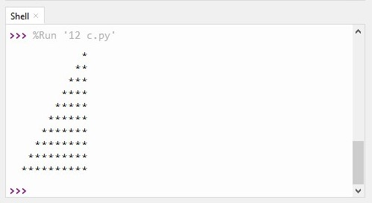

**Conclusion:**

Today I learn how to write a program which calculate the value of “e” and implement which Ask the user to provide final exam marks of 10 students in *Introduction to Computing* course in order to calculate the average. Use *while* loop for this purpose, and use *break* statement to exit the loop when an invalid input (e.g negative number) is given. Moreover, if marks greater than 100 are given, use *continue* statement to skip that number from average calculation. And write programs that print following patterns separately.

